**INTRODUCION**

As I build my project on two DBMS one is MS ACCESS and the other is ORACLE 10g Server , SO now we are going to build USER INTERFACE , as we are going to take Oracle 10g server and it’s application to build User interface . HERE are instruction and step of HOW TO USE ORACLE 10G SERVER ,FORM BUILDER .first of all we are define what is oracle 10g server ? it is server that run all applications , it is database where we perform DDL , DML

Etc. then the Secord part come. ORACLE FORMS Services which is component of ORACEL 10g it gives us another user environment where we build (GUI) Graphical user interface . Now discuss some step and instruction

**First intro of FORM BUILDER FUNTIONS**

* **COMPONENTS OF FORM BUILDER**
* **FORMS MODULE TYPES**
* **OBJECT OF FORM AND BLOCK DEFINITION**
* **BLOCKS**
* **PROPERTY CLASS**
* **VISUAL ATTRIBUTES**
* **CANVAX WINDOW AND ALERT DEFINITION**

**FEEDBACK**

We made relationship build two thing one is ERD diagram which was for oracle 10g and second we build was ER model on the MS ACCESS therefore the requirement we had cleared , as was know

* **ER model**

ER model describes the relationship between entities and their attributes

* **Relational model**

It referred to the implementation of our model.

**Normalize**

As on the feedback , the normalized schema presented as a ER model has still difference ;

Example there Is no proper distinction between crew and pilot

So we made a new column for making distinction between them which is C_PILOT_FLY_A and we already made the column of C_Designation where we can watch who is pilot and hostess easily. We are going you source code of 10g there is file name backend of **feedback and form builder codes.**

where new columns will be added in **crew table** .column name C_PILOT_FLY_A

**COMPONENTS OF FORMS**

We have four components here

* **Object navigator**
* **Property palette**
* **Layout editor**
* **PL/SQL Editor**

These components are going to build our graphical user interface

* **OBJECT NAVIGATOR**

The object navigator is browsing and editing interface of oracle form builder we can use object navigator to manipulate application object.

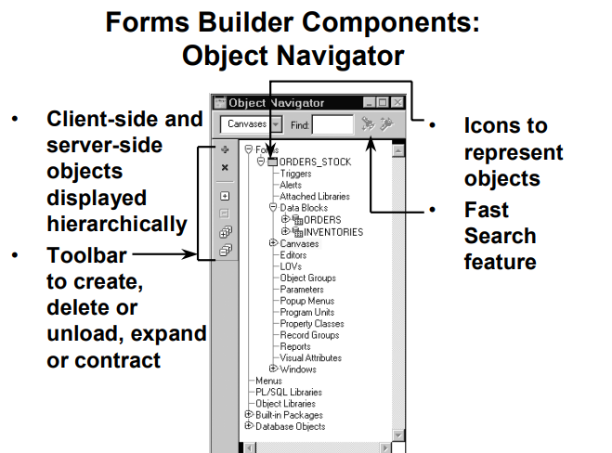

Interface components of the forms builder tool help us to provide productivity of oracle forms builder environment.

* **Property palette**

Each and every object ,module have property ,So property palette is also there for modify property of object and modules.

* **Layout editor**

We also call layout editor as layout model it is a graphical design where we creating interface ,item and graphical objects in our application

* **PL/SQL Editor**

We use PL/SQL to create trigger, it like development of triggers,when ever we are going to make button through triggers.

## FORM MODULE TYPES

## FORM MODULE

## MENU MODEL

## FORM MODULE

## It is collection of object like block ,canvax items and pl/sql

## MENU MODEL

It is one of collection menu items. It can be main menu or sub menu.

**Instruction of create new form model**

|  |  |  |
| --- | --- | --- |
| **STEP** | **INSTRUCTION** | **FORM BUILDER TOOL** |
| **1** | **First we had to create an new model** | **Object Navigator** |
| **2** | **And then making new block and items** | **Data Block wizard** |
| **3** | **And then applying user interface** | **Object Library** |
| **4** | **Then show the layout** | **Layout Wizard OR layout editor** |
| **5** | **After those we are going to work on object properties** | **Property palette** |
| **6** | **Add code** | **PL/SQL editor** |

**OBJECT OF FORM AND BLOCK DEFINITION**

* **BLOCKS**
* **ITEMS**
* **CANVAS**
* **FRAMES**
* **WINDOW**

**FIGURE OF OBJECT OF FORM AND BLOCK DEFINITION**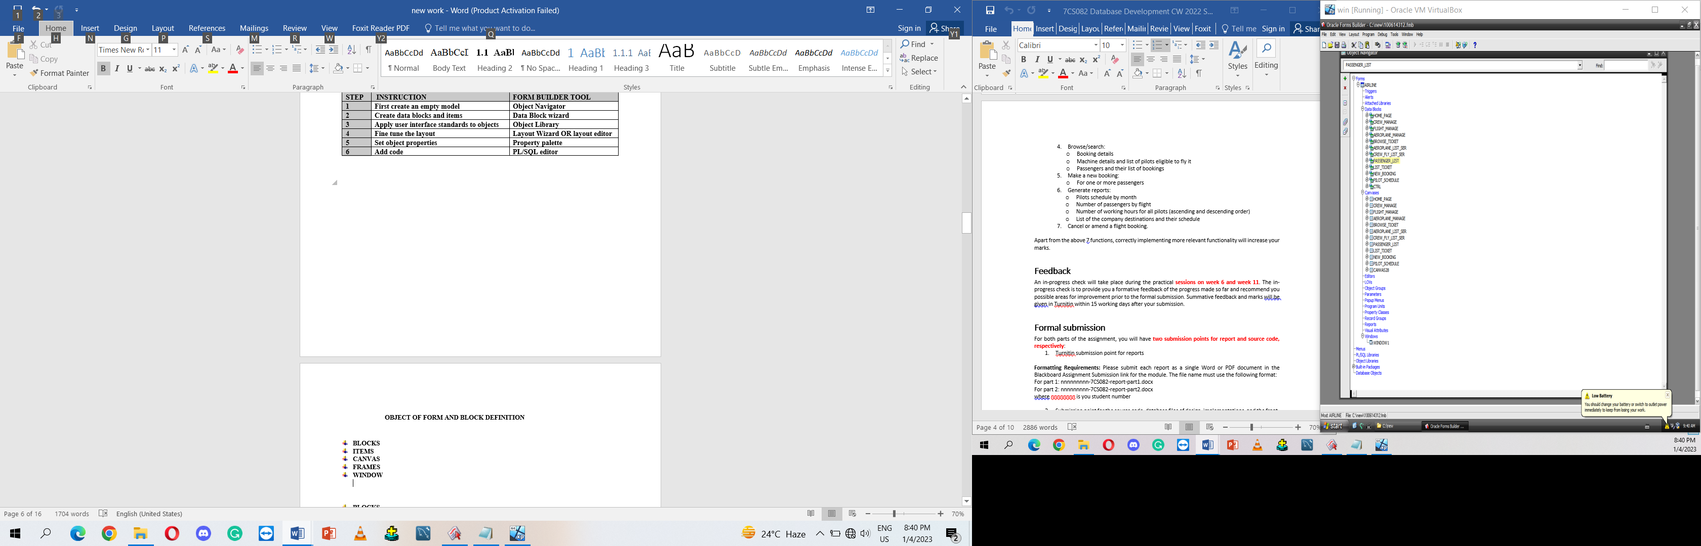

* **BLOCKS**

We use block for logical representation of item .it provide us mechanism of grouping related items into a function unit for storing.

* **ITEMS**

Item is an interface object which present data values to the user.

* **CANVAS**

Canvas is the background object . which cares item of interface

* **FRAMES**

We use frames for arrange items with the block

* **WINDOW**

Window is visual object that make a form builder application

**BLOCK**

As we know block is logical representation of item ,which provide us mechanism of grouping related items into a function unit for storing.

It has two parts

* Data block
* Control block
* Data block

Data block are related with data table in a database. It related between data block and the database which allows us to operate the query ,update ,insert and delete rows in the database .

* Control block

A control block is not same as data block it don’t associated with the database , and the items in a control block do not relate to table column in database

**PROPERTY CLASS**

Property class , the object is named that contains of properties and their associated settings , once we create property class we can based on other objects on it, the objects are based on the property class settings of any property in the class that is appropriate for that object.

There are 2 ways to create property class

* Object Navigator method.
* Property window method.

## VISUAL ATTRIBUTES

Visual attributes are the color,font,and pattern properties that you set for form and menu objects the appear in you application’s interface .

Visual attributes properties are font name , font size ,font style , font width ,font weight color and pattern properties ,filling color in backend or foreground

**CANVAS WINDOW AND ALERT DEFINITION**

* CANVAXS

CANVAS are object represent which care entity of interface item , such as check box ,radio groups and text item , there are four tapes of canvas objects.

* **Content CANVAS**
* **STACK CANVAS**
* **TAB CANVAS**
* **TOOLBAR CANVAS**
* **CONTENT CANVAS**

IT is most common canvas type, it is base view that occupies the entire content pane of window in which it is displayed , we must be define at least one of content canvas for window creating

* **STACKED CANVAS**

A stacked canvas is displayed , stack canvas is content canvas which assigned to the current window ,stacked canvased obscure some part of the underlying and we often that it hidden programmatically .

* **TAB CANVAS**

The TAB CANVAS made up of TAB page which allows us to display large amount of data of related information on the **form builder** canvas object ,like stacked canvas we are going to display on the top contact canvas.

* TOOLBAR CANVAS

A toolbar Canvas often is used to create toolbars for the windows, we can create two types of toolbar canvases ,horizontal or vertical ,horizontal tool bar canvas display is at the top window and just under the menu bar , and the vertical toolbar canvas display on far left edge of window

**I want to show you hidden canvas by programming pl/sql code we assign these code to button**

Show_view(‘HOME_PAGE’) OR we can write another code SET_VIEW_PROPERTY(‘HOME_PAGE’ visible ,property true)

Hide_view(‘HOME_PAGE’) OR we can write another code

SET_VIEW_PROPERTY(‘HOME_PAGE’ visible ,property false)

**Window**

It is container of all visual object that make up Form builder application also canvases ,if we build a form it contain any number of windows, we also create additional windows as much as we want on the base of need, we inserting them under the Windows node on the Object Navigator.

**ALERT**

Alert is a model window which display message notification of operation

We use alerts to advise operators of unusual situation or to warn operators which are about to perform

An action that might have undescribe

**CONNECTING DATABASE TO FORM BUILDER**

As we know Oracle 10g server is the database , and now when we making our project we have to build a

Connection to oracle 10g, so we just have to open an application named OC4J Instance ,it will connect and show our java development environment .

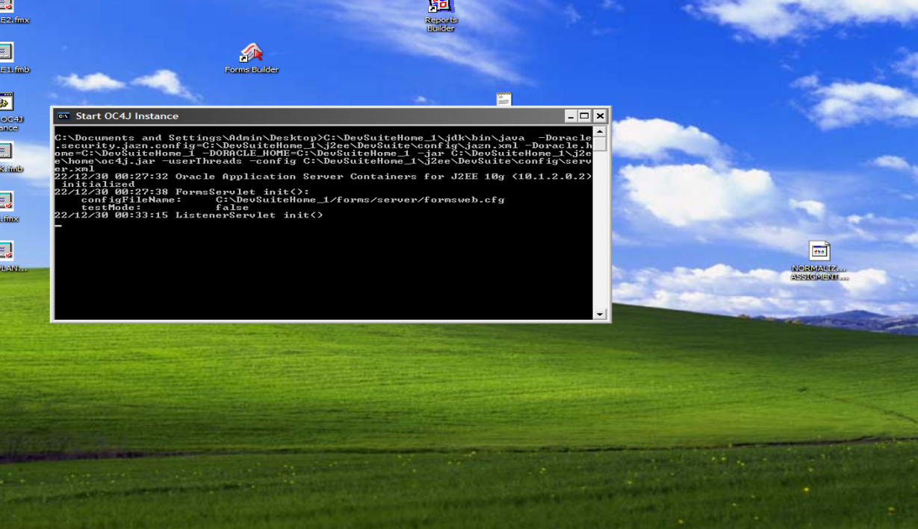

This is figure of starting OC4J

We connected OC4J there is another connection which is for given privilege to connect the database now we just open our **form** **builder** application, So that we could make project simply if your are going to BUILD new FORM , MODULES or any object it just ask you about connection where you give default password like here given

Our whole work is on the **data block** ,**Canvas ,Property platter** so simply us are going to create

**STAGE OF CREATE DATA BLOCK**

When we build a data block there is windows tabs open which ask about how do we want to create or build data block . we will make two block on **building a new data block manually** remaining block will be made on **Block wizard**.

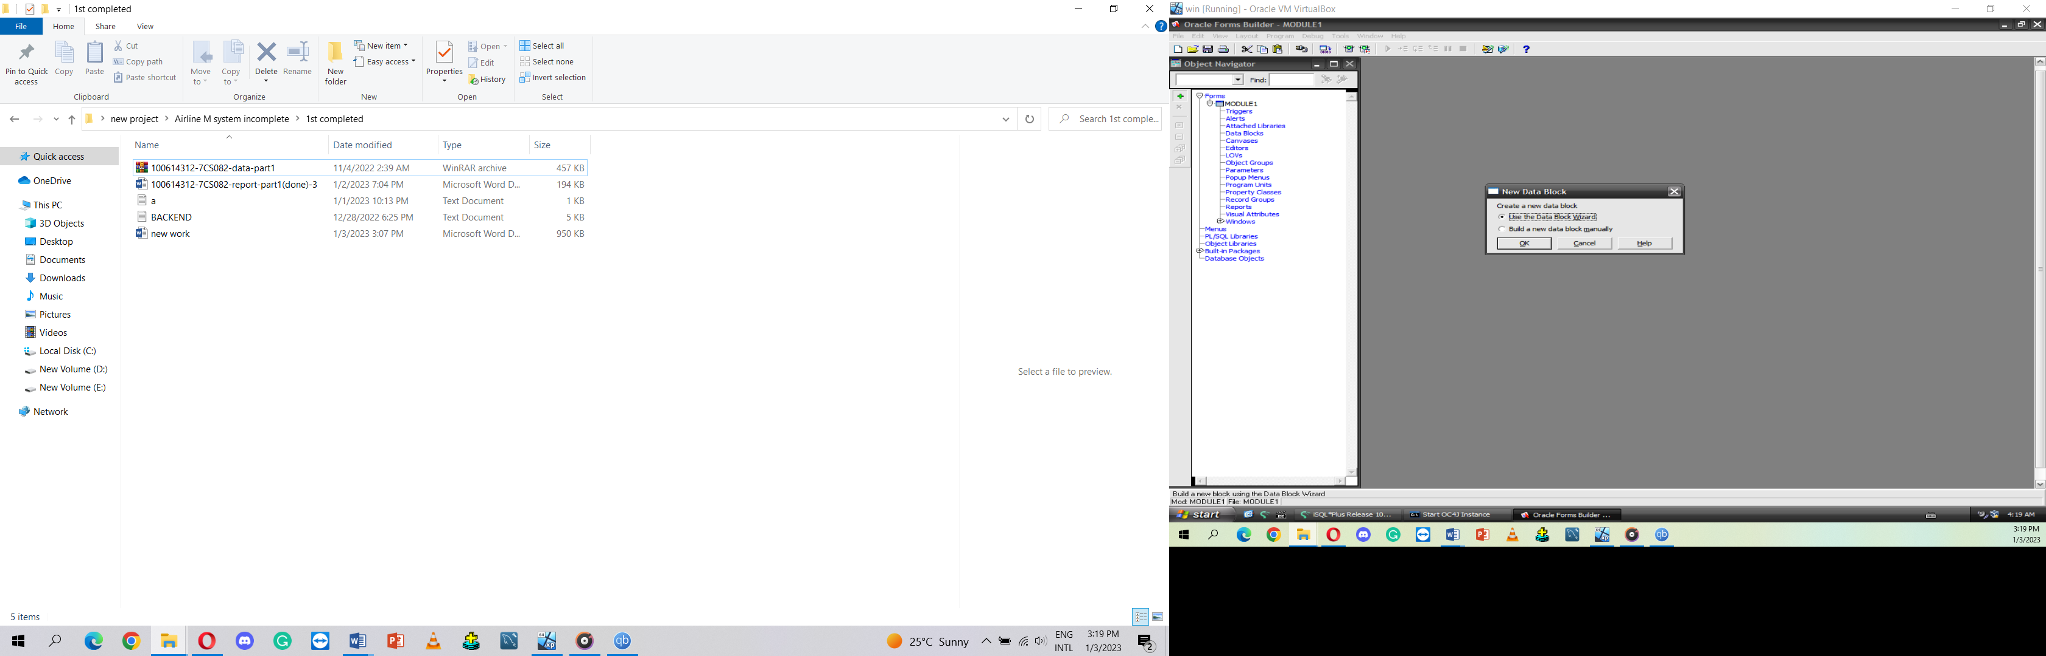

**First , we made home page data block and canvas**

* **We made eight button which has the access of going to next block and also had direct view of data through EXECUTE QUERY is the code for view date on the block**

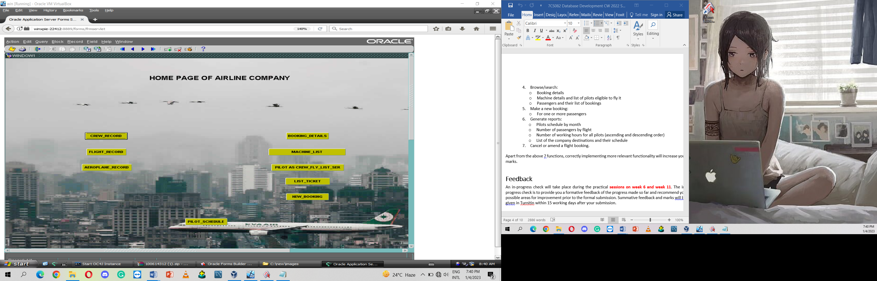

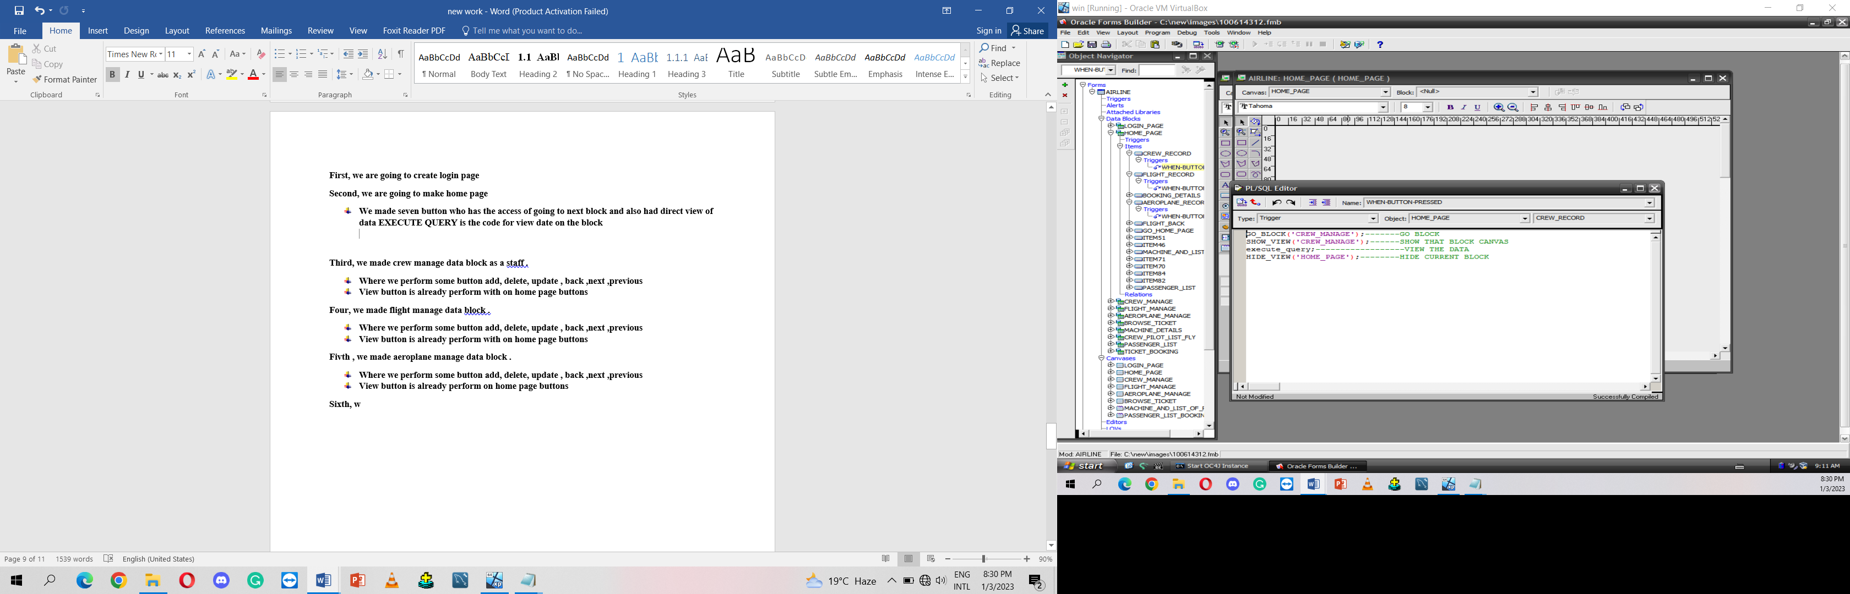

**Second, we made crew manage data block as a staff .**

* **Where we perform some button add, delete, update , back ,next ,previous**
* **View button is already performed on home page buttons**

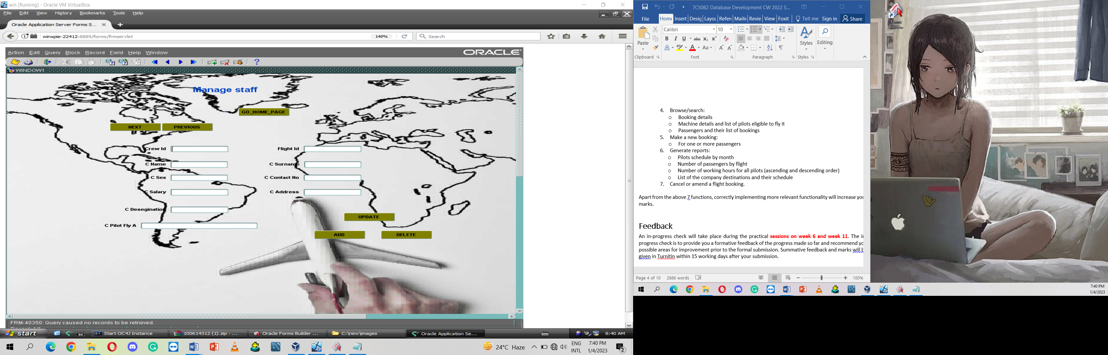

**thired, we made flight manage data block .**

* **Where we performed some button add, delete, update , back ,next ,previous**
* **View button is already perform on home page buttons**

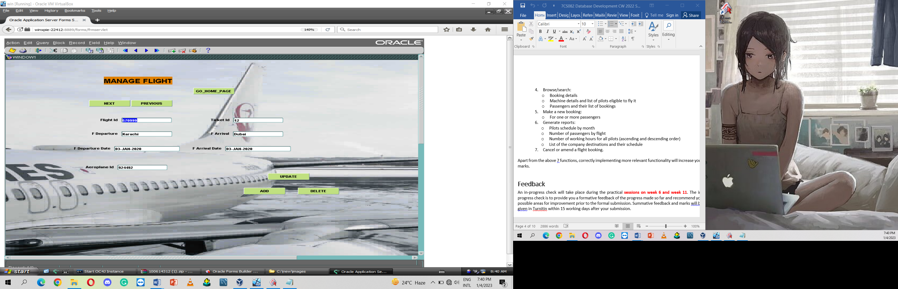

**Four, we made machine as an aeroplane manage data block.**

* **Where we performed some button add, delete, update , back ,next ,previous**
* **View button is already perform on home page buttons**

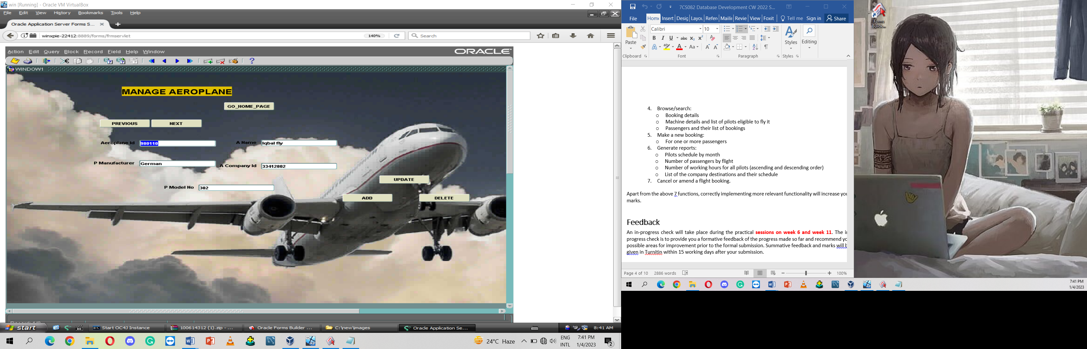

**Fivth, we made browser ticket which is booking details**

* **We performed some button back and search**

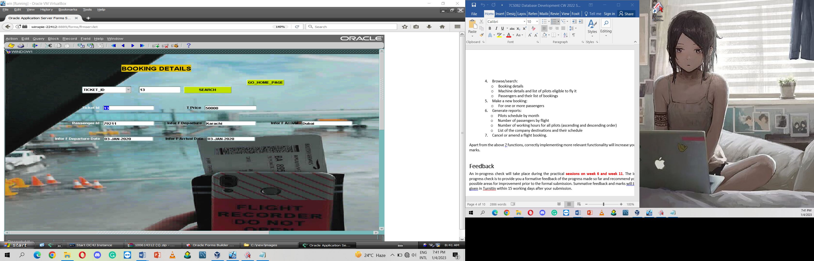

**Sixth, We made MACHINE DETAILS as an AEROPLANE_LIST_SER data block and canvas**

* **MACHINE_DETAILS which care AEROPLANE_LIST_SER**
* **Two buttons one is search button second back**

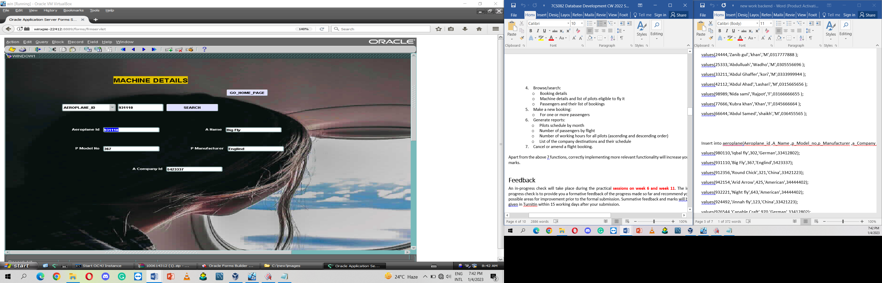

**Seventh, we made list of pilot as AEROPLANE_LIST_SER data block and canvas**

* **We performed some button back and search**

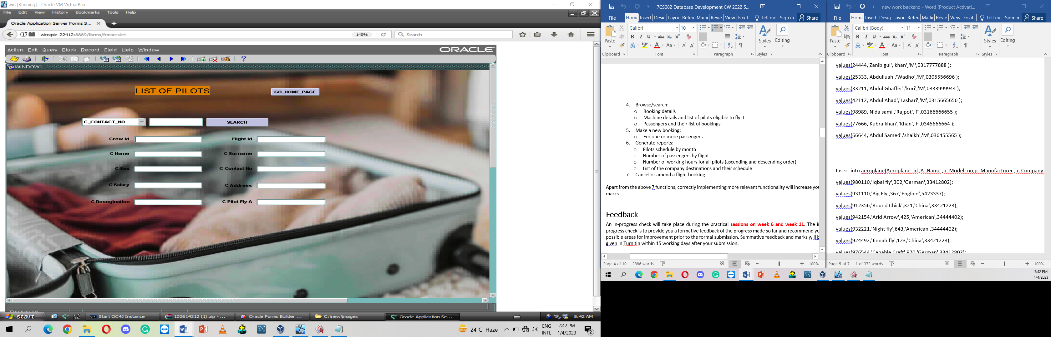

**Eighth, we made contact canvas where we made two table PASSENGER LIST and LIST TICKET as PASSENGER AND THE LIST OF BOOKING. those DATA BLOCK care Ticket tables and Passenger table.**

* **We performed some button back and search**

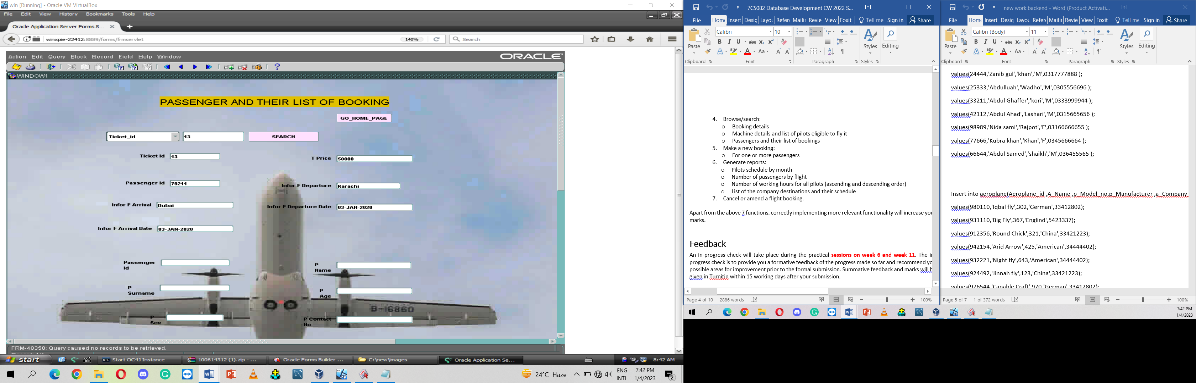

**Ninth, we made MAKING NEW BOOKING as NEW BOOKING data block and canvas names.**

* **We performed some button update , add ,back**

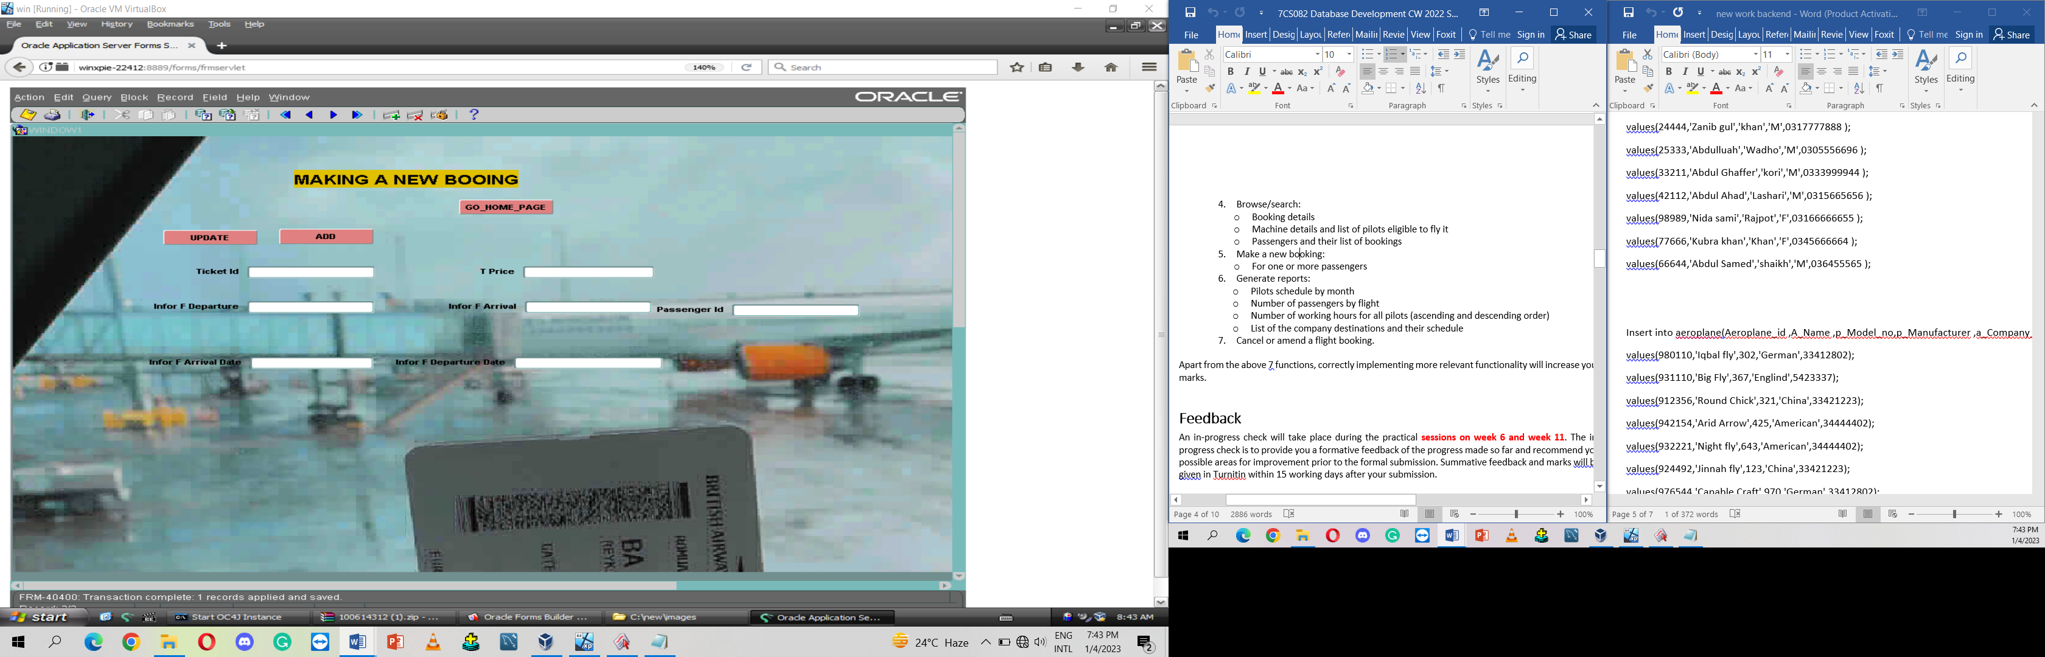

**Tenth, we made PILOT SCHEDULE BY MONTH as PILOT SCHEDULE data block and canvas names.**

* **We performed some button update , add ,back**

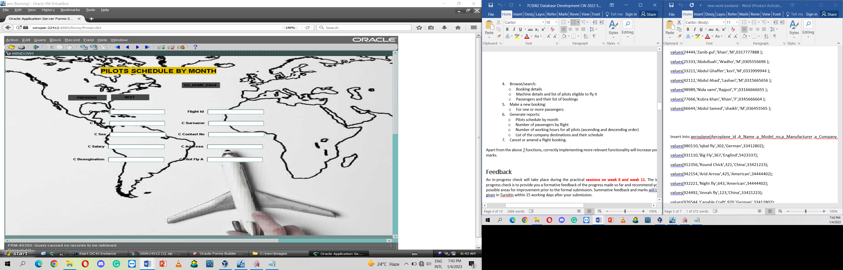

**Eleventh is last data block whose name is CTRL it is base block for All search button, In other word it is the address of all SEARCH BUTTON.**